Graph Theory Project 2017

*Kelvin Murphy*

*G00311695*

Design and prototype a Neo4j database for use in a timetabling system for GMIT.

For my third year project in the module Graph Theory we have been asked to detail and create a working prototype of a timetabling system for a third level institute, using a prototype neo4j database. I have chosen to detail a plan and create my graph-based database on the GMIT Galway Campus and more specifically Third year software development, which is my own class.

I thought that by using my own timetable it would feel more familiar to me and I would find it more comfortable working with it as I could see nodes as more than just information bubbles and see them as people and classrooms. By seeing them as real objects it will make it easier for me to rationalize them and store them in the database.

The reason why I am going to recreate the timetable using a graph based database is to show what I have learned over the semester in this module and by detailing and creating a graph database I am showing that I understand the concepts of Graph Theory, and that I am able to solve problems using graph based solutions, both simple and complex in this module by what I have learned over the last semester.

I will update and commit my written document outlining everything I plan to do and my actual project to github on a regular basis as to keep all of my work up to date and also it is a handy back up because if my computer crashes I will have all my information on github and can simply take it down off of github on to another computer and continue my work.

I have decided to use Microsoft word to write my document and Neo4j community edition to create the graph database. I have never used neo4j before so this will be and interesting earning experience for me.

My database will store all the necessary data to form a working usable timetable. It will store the rooms as nodes so they can be easily attached to on the graph to other nodes. It will store the three different classes as nodes so they can be connected to other nodes. It will store the time slots and the sate slot, again as nodes so that they can be joined up and used with other nodes. The database will store the lecturers as nodes to make sure they are not otherwise busy and can be put in with a certain class at a certain time. Lastly it will store the subjects (modules) for the course, again these will also be stored as nodes so that all of the above, the rooms, class groups, time/date slots, lecturers and subjects can all be interconnected on the graph and therefore create a graph that will allow all of these to work together without overbooking any one node.

All of these nodes then interconnect to create a complex graph that I will use neo4j community edition to create. It will then store as many nodes as I add to it but for this timetable project the only nodes I need to use in order to fill out the graph and timetable are the ones I listed below.

|  |  |  |  |  |  |  |  |  |  |  |
| --- | --- | --- | --- | --- | --- | --- | --- | --- | --- | --- |
| |  |  | | --- | --- | | Rooms | Node | | Class Groups | Node | | Time/Date Slot | Node | | Lecturers | Node | | Subjects | Node | |

A simple diagram shows how these are stored, keep in mind that these are only the main headers and each of the above has many nodes not just one.

A more detailed sub diagram to show all the sub categories under the main ones will be more helpful into understanding how these are stored so I will create a table of all the sub categories as there are a numerous amounts of each of the above nodes.

|  |  |
| --- | --- |
| **Group** |  |
| A | Node |
| B | Node |
| C | Node |
| **Lecturer** |  |
| Ian Mc’Loughlin | Node |
| Martin Hynes | Node |
| Damien Costello | Node |
| Patrick Moran | Node |
| Gerard Harrison | Node |
| Deidre O’Donovan | Node |
| **Subject** |  |
| Graph Theory | Node |
| Database Management | Node |
| Server Side Rad | Node |
| Mobile Applications | Node |
| Software Testing | Node |
| **Rooms** |  |
| 145 | (room is no longer used) |
| 994 | Node |
| 223 | Node |
| PF 05 | Node |
| 481 CR4 | Node |
| 436 CR5 | Node |
| 482 CR3 | Node |
| 470 | Node |
| 379 | Node |
| 162 | Node |
| 938 | Node |
| 208 | Node |
| 997 | Node |
| 939 | Node |
| 995 | Node |
| PF 18 | Node |
| 483 CR2 | Node |
| **Time/Date** |  |
| Monday – Friday | Every day here is a node |
| 9:00 – 18:00 | Every hour here is a node |

The Database will store all of this information.

Its interesting how Neo4j works by creating a graph based database and could come in very useful in lots of different types of databases but for me and right now the timetable seems to be best suited to use the Neo4j community edition to create a graph for it. It is designed around relationships with its nodes and it is the most popular of all the NoSql databases. It has huge scalability that can reach billions of nodes, however I won’t be using near that amount, a site however that would use that many would be Facebook.

Neo4j works by retrieving information based on interconnections between data rather than the orthodox Sql where it runs through the data systematically to find the information. It is and open source and is supported by Neo Technology hence the name Neo4j (Neo for java). Directional relationships in graph databases have properties that describe them and all nodes are connected to each other making the directional relationships work. Labels are also used in Neo4j, all nodes with the same label are part of the same group just like in the examples above. A property is like a label but with a key value pair that’s part of a node or relationship. Every relationship has a type in Neo4j and this is key to navigate the graph.

Simply put Neo4J finds relationships (connections) between nodes (data) and in turn finds their value.

I have decided to write out a strategy to help me to structure and to tackle this project. I’m going to download Neo4j and create a local host.

I’m going to start by doing some simple tutorials to get myself used of using the layout and feel comfortable when it comes to dong my actual graph from the timetable. When I am comfortable with Neo4j and its layout I will then create and new folder for my actual timetable project. I will commit it to github at regular intervals with decent amounts of work and code put into each commit to make sure all my data is safe.

I’m going to start my graph by creating the parent single node that will be Third year software development, I will then give that children which will be the days of the week. From the days of the week will then come the children nodes Groups, there will be four of them, Group A, Group B, Group C and Group AT for when all the groups are together in the same class.

Next is to set up more nodes as the subjects and have relationships with them and the groups and days.

So far it should be pretty simple as there is nothing to clash with each other. The next step in setting up the lecturer nodes, times nodes and room nodes will be more difficult as these can be used up so the graph needs to be laid out correctly with correct instructions, nodes and relationships in order for all this to implement and work together.

The local host page that I will be creating this on is very well set up and has lots of tutorials and helpful hints to get my own graph representation working well and looking neat.

To implement all of my nodes on my graph I will be using cypher as it’s the default language and best one to use on the Neo4j local host page.

I thought about scraping all of the GMIT room numbers from the actual timetable site but that would just leave a lot of unused nodes floating around my graph which would look very messy so I decided to just put in the rooms we used this semester as then there will be no left over nodes as room. Another aspect I implemented was filling in the graph and nodes all manually as this way I have complete control and know everything and all the information that is going into my graph. I then implemented all the relationships between all the nodes and created a graph in Neo4j using cypher and this document guide lining myself to recreate a third year software development timetable. I created a .gitignore file through terminal and added .DS_Store as this causes problems from a mac when uploading and downloading from github.

Once my graph was complete I started querying it to see if it would work properly, this is some of what I queried and the answers to that query. I found that for the more intricate searching query the command ran correctly but did not give me any feedback and this puzzled me as I could not figure out why. I first thought that because the simple ones worked it must have been the way I worded the queries wrong even though they ran and compiled with no errors. There were a lot of stumbling blocks on this project like how these queries wont show my graphs but I enjoyed learning about neo4j and cypher and feel I am better-equipped next time to tackle a project like this.

MATCH (n) RETURN n

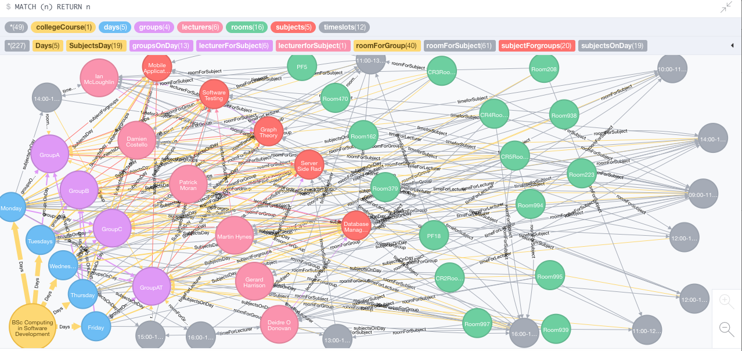 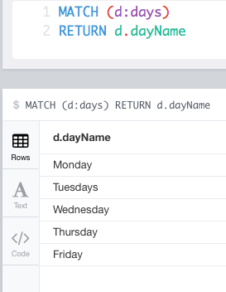

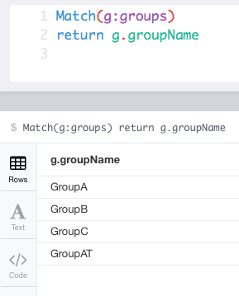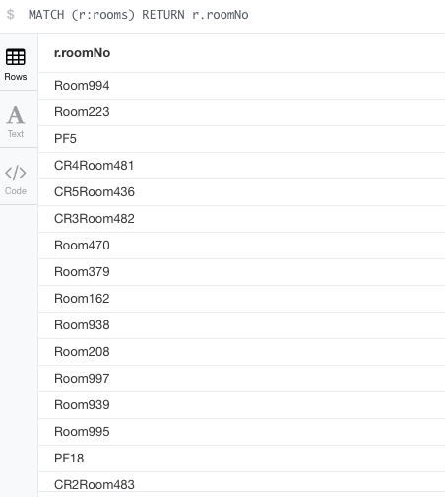

Some of my queries are written properly as the machine accepts them but it does not give me any feedback like this some of these

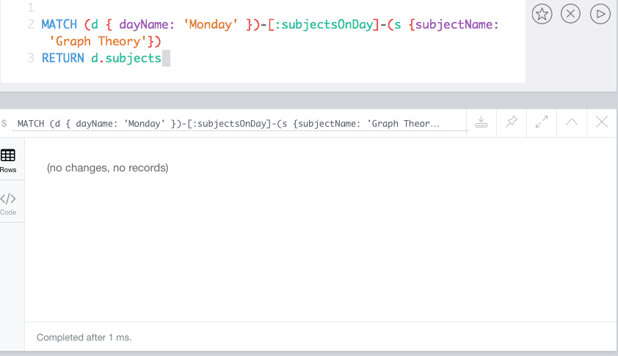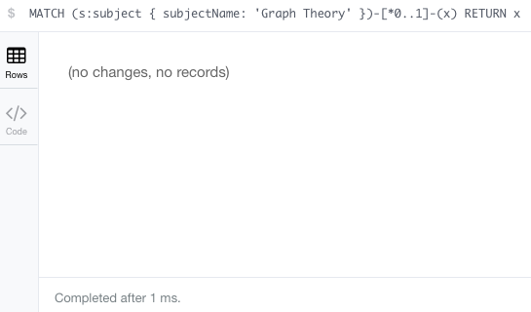

In Conclusion to this project I feel it was a good success and I learned a lot from it. The reason I feel it was successful is because I now have a graph database using Neo4j representing a third level institute timetable. A few things did not work out for me like trying to import into Neo4j and I changed a couple of ideas along the way such as scraping all the room numbers from the timetable but despite these I worked around them, and with that and keeping to my own guidelines I set out in this document I successfully created a graph database. For the most part of this project I did everything from my notes and my own initiative however some things I couldn’t figure out on my own and used the help of Google and I will reference all sites that helped me to create this Graph based database at the end. I feel this project will be very useful to me in the future if ever asked about Graph based databases or neo4J.

References:

* <http://stackoverflow.com/questions/31485802/how-to-return-relationship-type-with-neo4js-cypher-queries>
* <https://neo4j.com/developer/language-guides>
* <http://stackoverflow.com/questions/35281066/neo4j-is-it-possible-to-visualise-a-simple-overview-of-my-database>
* <https://www.youtube.com>
* http://www.quackit.com/neo4j/tutorial/neo4j_delete_a_relationship_using_cypher.cfm